|  |  |
| --- | --- |
| Module name | Login |
| Test Case ID | TC 1 |
| Tester Name | Devendra Mali |
| Taste Case Description | To check login functionality of Google |
| Prerequisites | 1. Stable internet connection 2. Browser(All) |
|  |  |
| Environmental Information | 1. OS: Windows/Linux/Mac 2. System: Laptop/Desktop |
| Test Scenario | Checking That after entering the correct username & password, the user can login |

Scenario 1

|  |
| --- |
| 1.Enter Username  2.Enter Password  Scenario 2  1.Login With Blank Fileds  2.Login with invalid Creditional  Scenario 3  1.Click on Login  2.welcome back User  Scenario 4  1.Welcome User |
|  |
|  |
|  |
|  |
|  |
|  |
|  |

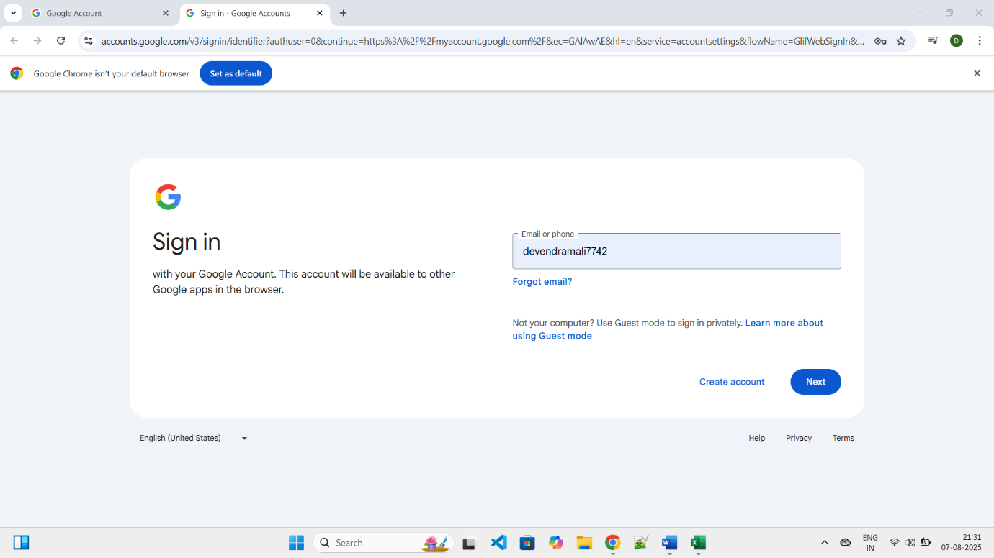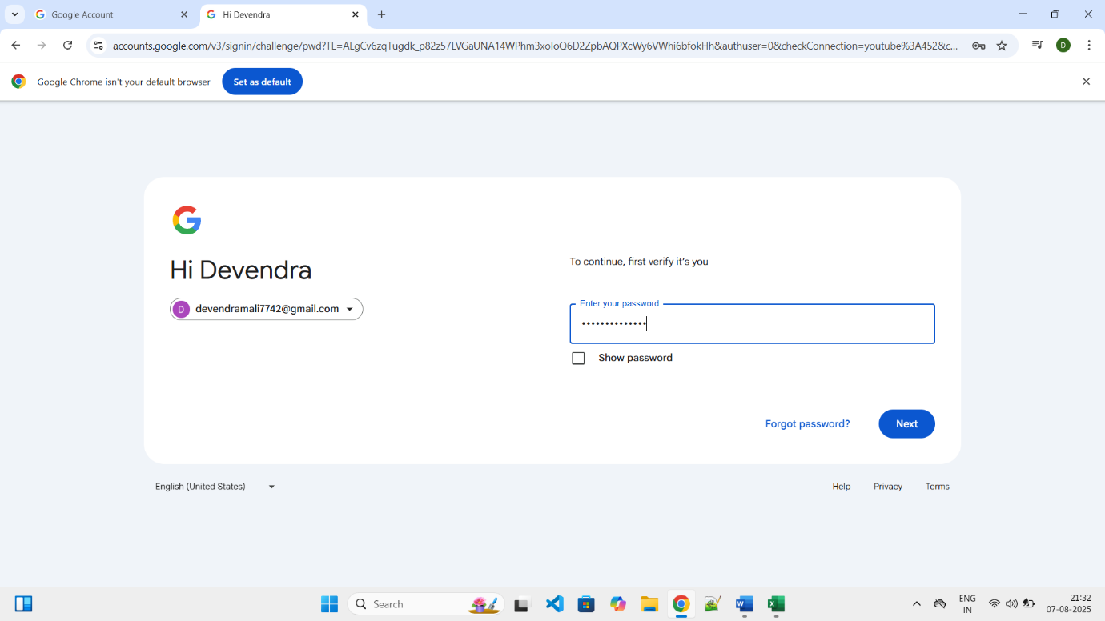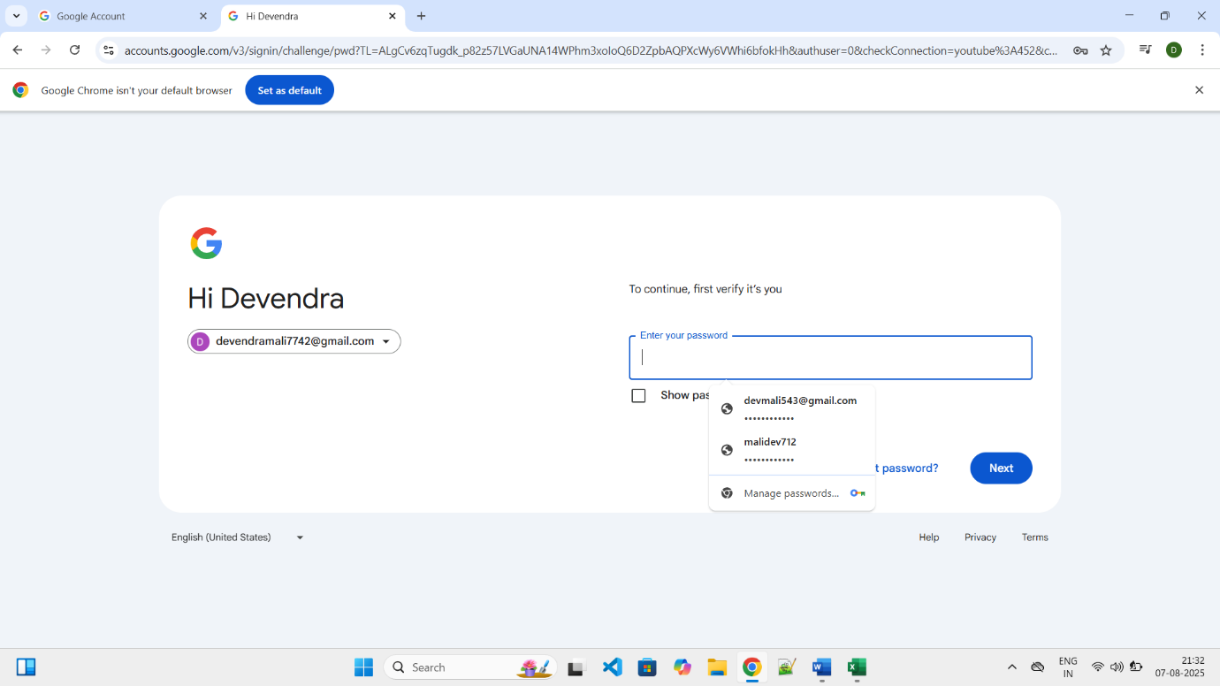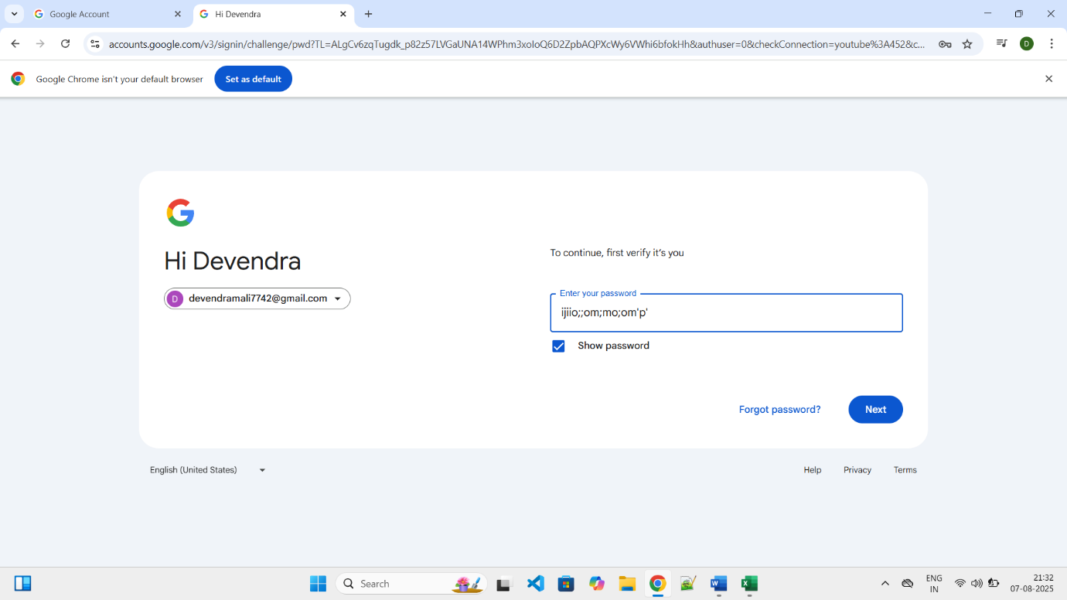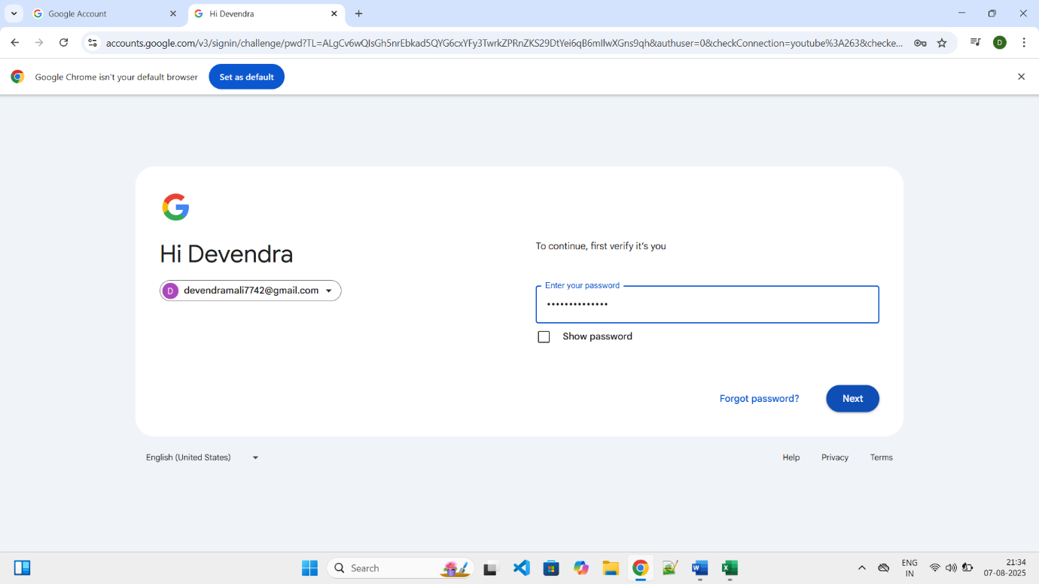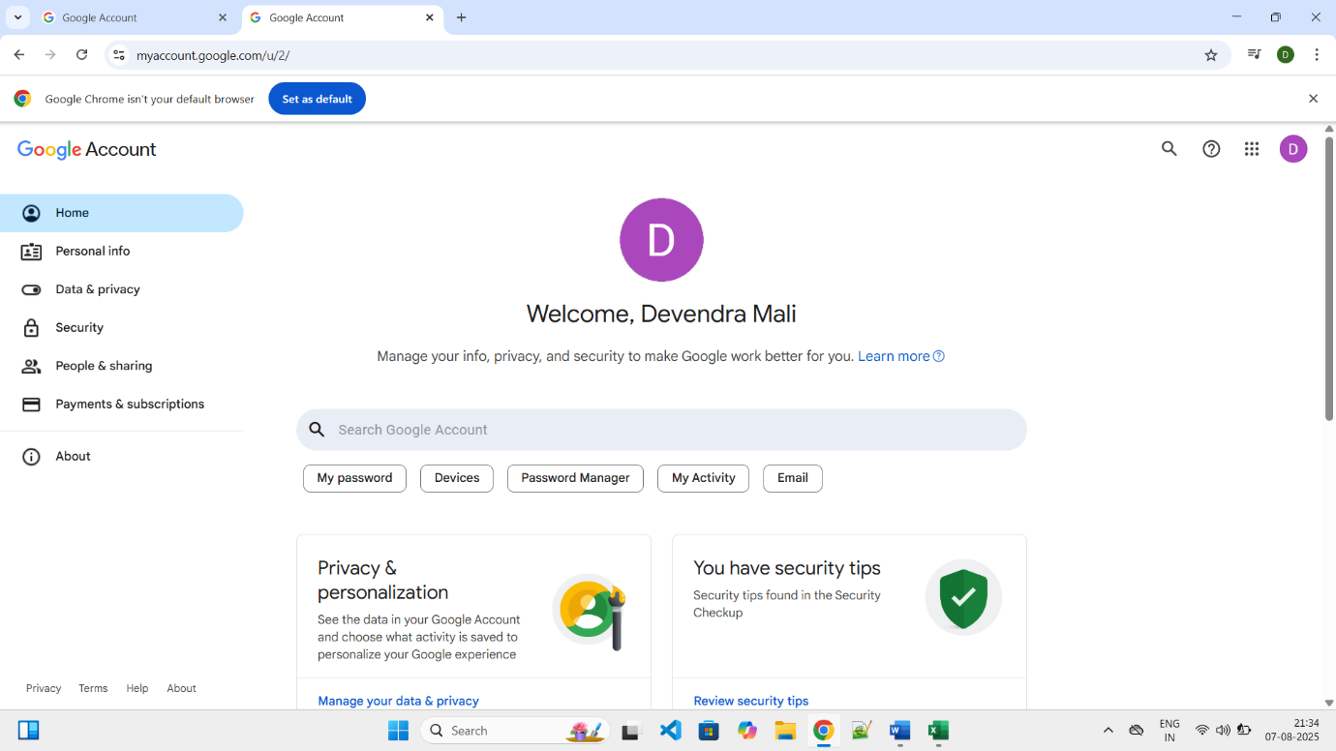  
  
  
Summary Of Test Results:   
Total Test Cases- 7 Passed- 7 Failed- 0 Pass %- 100%   
● Conclusion and Recommendations: Pass Rate: 100%, No Need Improvement  
● Issues Found 0   
Bug Reports:   
1. Field Description Bug ID BUG-1   
 1. Click on Sign Up   
2. Enter existing Email  
 3. Fill all fields   
  
4. Click on Sign Up the cursor show the name of attempt to Relogin